|  |  |
| --- | --- |
|  |  |
| Assembly Project |  |
|  |  |
|  | Date Due: 1st of MarchProject: Endless Runner |
|  | Student Name: Kyle KinsellaStudent Id: C00273146 |

Introduction

For this project we were told that we will have to make either an Endless ChatGBT or an Endless Graphical Runner. So, on each day that I had computer architecture class I was trying my very best to try and learn the basics of assembly language, in order for me to be able to make a basic game. My lecturer gave use a starter kit, this was very helpful as I could have a look at the code for certain things, I could change values, data registers and lots more. This was very beneficial to me because after using the starter kit for a few days I was starting to get more comfortable writing code in assembly language. I then started to add in my own code to the starter kit in order to change the starter kit into an actual game.

Then I was starting to come up with an idea for my game. The idea that I came up with was that I have a character roughly in the middle of the screen and have an enemy coming towards you. In order to play the game you will need to press the spacebar to jump and when you die press the enter key to restart the game. In my flowchart I have just summarized the whole purpose of my game. See the below flowchart for more information.

Flowchart

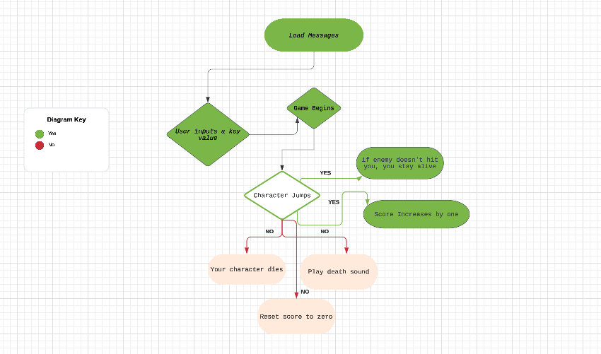

Problems with my project

When I was creating my project, I encountered a good few problems. I am going to go into a bit of detail of each problem I had and how I fixed it.

1. Menu before the game starts.
2. My character jumping.
3. The score
4. The death sound.
5. How to restart the game
6. Like any normal game before you start it you want to be ready to play the game. But when I was building my game I had not build this yet due to testing purposes. But when I was trying to build it I was having one error and I could seem to figure it out then I soon realized that it was a spelling error, this must have happened when I had declared that certain variable that I was trying to access.
7. The main action in my game is to be able to jump, if you cannot jump you will die and keep dying! I got my character to jump but when you hit the spacebar he would jump and then immediately fall back down, I didn’t want this to happen! I wanted him to jump and then fall a bit slower. So I want off to google and was looking for quite some time but I found some code that I thought might help me and I implemented that code into my game and I got my character to fall a bit slower.
8. Another main function for my project is the score. The score shows you how well you are doing in the game. At the start I had the score working but it was incrementing extremely quick. So, I found the piece of code for the score in the starter kit and changed a few things around, for example I changed a data register from D3 to D4. I then used this code in my game and it still wasn’t working properly so I moved a few things around and changed a few values and then I got it to work. I have it working as best as I possible can at the moment, I wanted the score to increment by one each time you jumped over the enemy and didn’t get hit, it does do that but the score is a little bit delayed.
9. When I was coming close to finishing my project, I had when the enemy hits you or you hit the enemy, you die, I was thinking to add a death sound when you die but I thought it was going to be to hard. But then I had a think about it and then came to the conclusion that I was going to try and get a sound to play when you die. I implemented the code that I needed to play the sound but it didn’t seem to work. So, I asked one of my lectures for some help, the lecturer could not seem to figure out why it was not working, so I tried asking my other lecturer and he asked me a few questions and one of them was how big is the file, he said to me if it is more than 8 bytes it wont work. So I went off and got a 8 bit wav death sound file and I got it to work.
10. When you die in any game, there must be a way to restart the game, as this is a very important feature for the user playing the game. Before the game starts I have a message for the user to press the enter key to start the game, I am stating this here because I am re-using this code when you die. So, when you die you get a message and then the systems wait’s for an input, when the user presses the enter key, under the hood it goes to a sub-routine in my code to wait for the user to input something and after that input the game then restarts / starts as it uses the same code.

Conclusion

While I found this project quite challenging and stressful for example, all the problems that I had with my project and how I fixed each problem, in order for me to fix each problem it took quite a lot of time and thought but I eventually resolved each problem. In making this project I have learned a lot, and this will hopefully continue in future projects and throughout my whole life. In my personal opinion I don’t think my game is great but I tried my very best to try and build a game, it has some good things in it for example, when you die the death sound plays, and some alright things, for example my score isn’t working 100% how I would like it but I tried everything and what I have in my game is the best I can get it. I hope you will enjoy playing my game, maybe I might make a better one in the future!